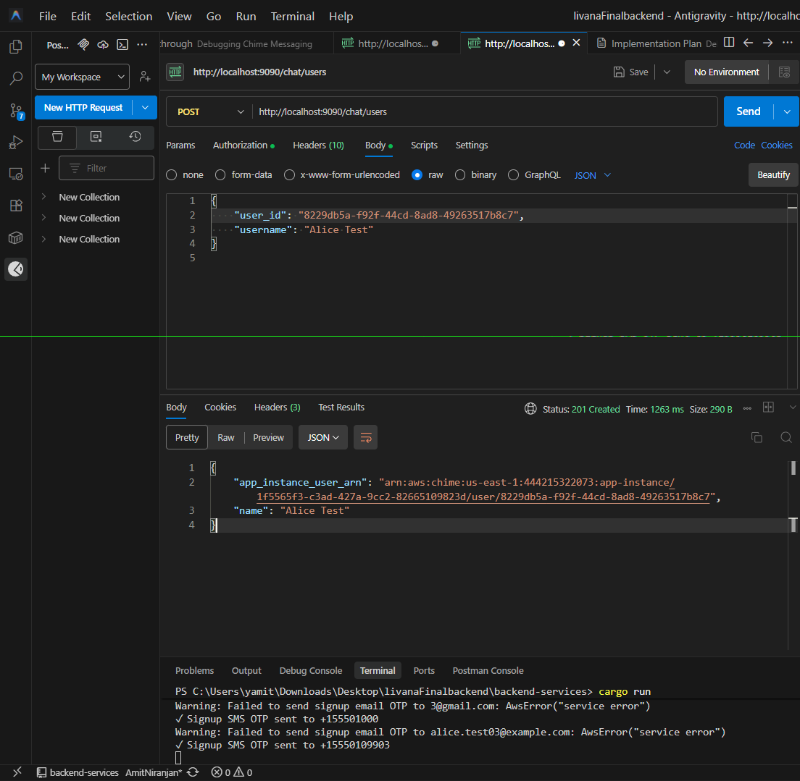



End-to-End Test: Signup to Chat
Follow these steps in Postman to test the full user journey.
Prerequisites
- Server running at http://localhost:9090
Step 1: Sign Up (Create New User)
Method: POST URL: {{baseUrl}}/api/auth/signup Body:
json
{
"firstName": "Alice",
"lastName": "Test",
"email": "alice.test03@example.com",
"phoneNo": "+15550109903",
"password": "Password123!",
"gender": "female",
"userRole": "user"
}
Response:
- Copy the token from data.token.
- Copy the user.id from data.user.id.
Step 2: Set Authorization Header
For all subsequent requests, go to the Authorization tab (or set manually in Headers):
- Type: Bearer Token
- Token: <paste_token_from_step_1>
Alternatively, set a header: Authorization: Bearer <your_token>
Step 3: Initialize Chat User (Important)
Explicitly create the Chime identity for this user. Note: We have implemented "lazy creation" in
send_message, but for creating a channel, you need the ARN first, so this step is recommended.
Method: POST URL: {{baseUrl}}/chat/users Body:
json
{
"user_id": "<user_id_from_step_1>",
"username": "Alice Test"
}
Response:
- Copy the app_instance_user_arn.
- Example: arn:aws:chime:us-east-1:1234567890:app-instance/.../user/...
Step 4: Create a Private Channel
Create a channel with yourself as a member.
Method: POST URL: {{baseUrl}}/chat/channels Body:
json
{
"name": "Alice's Private Chat",
"mode": "UNRESTRICTED",
"privacy": "PRIVATE",
"user_arns": [
"<app_instance_user_arn_from_step_3>"
]
}
Response:
- Copy the channel_arn.
Step 5: Send a Message (Updated API)
Method: POST URL: {{baseUrl}}/chat/messages Body:
json
{
"channel_arn": "<channel_arn_from_step_4>",
"content": "Hello! This is my first message using the new API."
}
Response:
- Body: { "message_id": "..." }
CommentCtrl+Alt+M
Postman Full Flow14 minutes ago
Review
End-to-End Test: Signup to Chat
Follow these steps in Postman to test the full user journey.
Prerequisites
- Server running at http://localhost:9090
Step 1: Sign Up (Create New User)
Method: POST URL: {{baseUrl}}/api/auth/signup Body:
json
{
"firstName": "Alice",
"lastName": "Test",
"email": "alice.test03@example.com",
"phoneNo": "+15550109903",
"password": "Password123!",
"gender": "female",
"userRole": "user"
}
Response:
- Copy the token from data.token.
- Copy the user.id from data.user.id.
Step 2: Set Authorization Header
For all subsequent requests, go to the Authorization tab (or set manually in Headers):
- Type: Bearer Token
- Token: <paste_token_from_step_1>
Alternatively, set a header: Authorization: Bearer <your_token>
Step 3: Initialize Chat User (Important)
Explicitly create the Chime identity for this user. Note: We have implemented "lazy creation" in
send_message, but for creating a channel, you need the ARN first, so this step is recommended.
Method: POST URL: {{baseUrl}}/chat/users Body:
json
{
"user_id": "<user_id_from_step_1>",
"username": "Alice Test"
}
Response:
- Copy the app_instance_user_arn.
- Example: arn:aws:chime:us-east-1:1234567890:app-instance/.../user/...
Step 4: Create a Private Channel
Create a channel with yourself as a member.
Method: POST URL: {{baseUrl}}/chat/channels Body:
json
{
"name": "Alice's Private Chat",
"mode": "UNRESTRICTED",
"privacy": "PRIVATE",
"user_arns": [
"<app_instance_user_arn_from_step_3>"
]
}
Response:
- Copy the channel_arn.
Step 5: Send a Message (Updated API)
Method: POST URL: {{baseUrl}}/chat/messages Body:
json
{
"channel_arn": "<channel_arn_from_step_4>",
"content": "Hello! This is my first message using the new API."
}
Response:
- Body: { "message_id": "..." }

